**Software Design Description**

**On**

**NSSTC e-Library System**

## 1. INTRODUCTION 3

1.1 PURPOSE 3

1.2 SCOPE 3

1.3 TECH STACK 3

1. **CONTROL FLOW DIAGRAM 4**

1. **ENTITY RELATIONSHIP DIAGRAM 5**

1. **ENTITY RELATIONSHIP MODEL 6**

1. **ENTITY DESCRIPTION 7-8**

## 1. INTRODUCTION

### 1.1 PURPOSE

* The purpose of this project is to provide a user-friendly digital platform for managing and accessing a collection of digital references such as e-books, e-journals, videos and other digital materials.
* This project is to provide an efficient information system for various types of references among NSSTC personnel, e-library members, and students.
* This System is a customized digital package designed to be used by Administrators, NSSTC personnel, and e-library members to enhance the user experience of students, researchers, and other library users by providing easy access to digital references in a single platform.
* The system provides a comprehensive search functionality, enabling users to easily search and retrieve relevant information. It also provides tools for managing user accounts, access permissions, and monitoring of e-Library changes such as modifying, adding and deleting outdated references.
* The e-Library System allows librarians to update the references, ensuring that users have access to the most up-to-date information.
* The purpose of this project is to provide a centralized digital repository for storing, organizing, and preserving digital references over time. The system will ensure the integrity and security of the digital collection, providing reliable access to users over the long term.
* The system provides a seamless user experience across devices and platforms, enabling users to access the digital collection from anywhere and on any device. The system will be responsive and optimized for mobile devices, providing a mobile-first experience for users.

### 1.2 SCOPE

1. Scope for managing digital references

The e-Library System will provide a user-friendly digital platform for managing and accessing digital references in the form of the following file types: PDF Document (.PDF) MSWord Document (docx) MS Powerpoint Document(.pptx) and (.mp4) for videos.

The system will allow e-library members and NSSTC personnel to easily search and retrieve relevant information from the digital collection.

The system will support the efficient circulation of digital references by managing user accounts, access permissions, and monitoring changes such as modifying, adding and deleting outdated references.

2. Scope for enhancing the user experience:

The e-Library System will be a customized digital package designed to be used by Administrators, NSSTC personnel, and e-library members to enhance the user experience of students, researchers, and other library users.

The system will provide a comprehensive search functionality that enables users to easily search and retrieve relevant information from the digital collection.

The system will be responsive and optimized for mobile devices, providing a seamless user experience across devices and platforms.

3. Scope for managing the digital repository:

The e-Library System will provide a centralized digital repository for storing, organizing, and preserving digital references over time.

The system will ensure the integrity and security of the digital collection, providing reliable access to users over the long term.

The system will allow librarians to update the digital collection with the latest references, ensuring that users have access to the most up-to-date information.

### 1.3 TECHNOLOGY STACK

This project was built mainly with the following programming languages and technologies:

1. JavaScript

2. PHP

3. HTML

4. CSS

5. MySQL(MariaDB)

### 2. CONTROL FLOW DIAGRAM

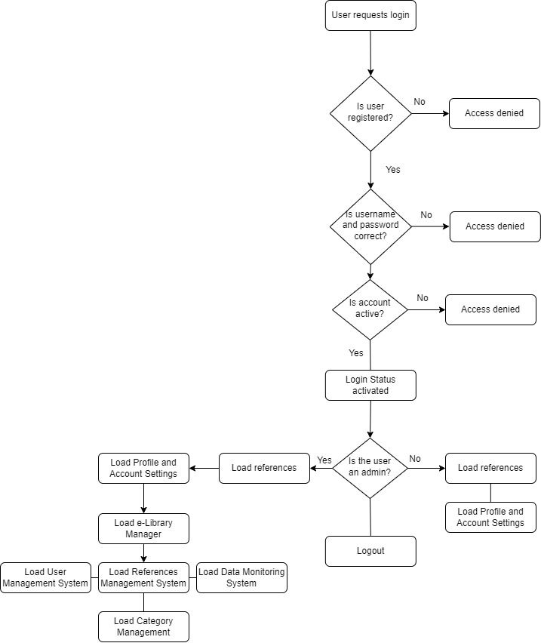

### 3. ENTITY RELATIONSHIP DIAGRAM

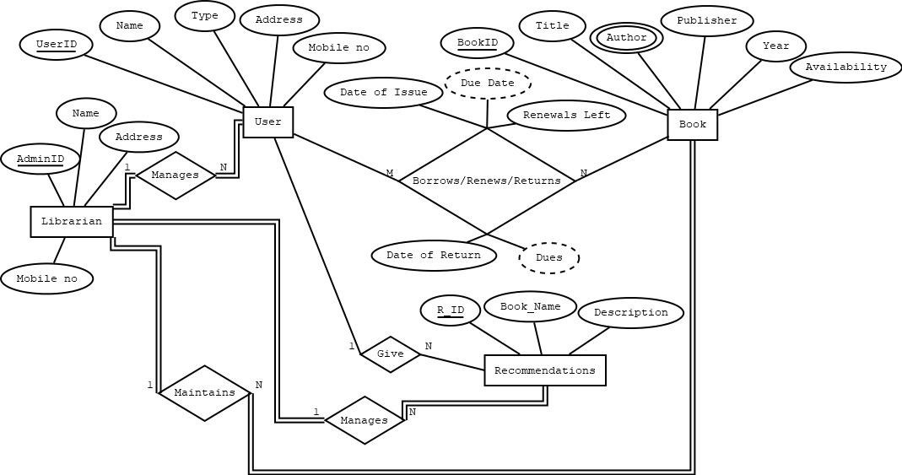

### 4. ENTITY RELATIONSHIP MODEL

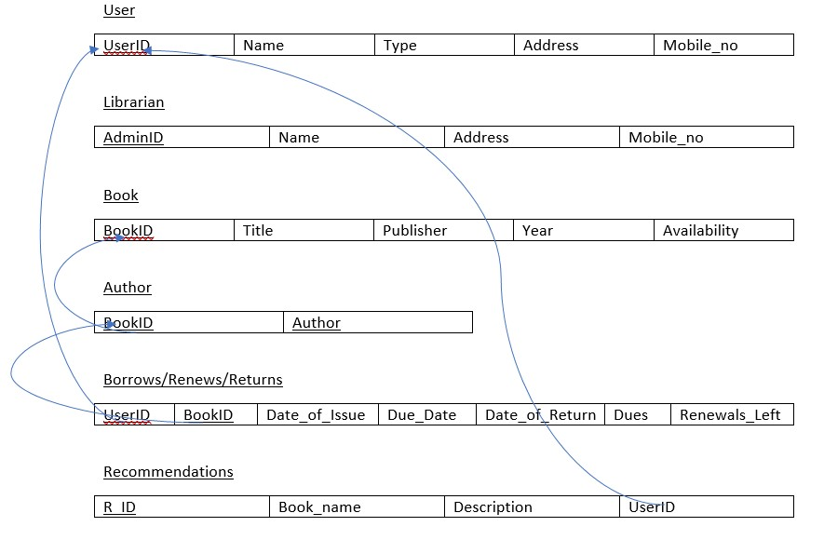

**5. ENTITY DESCRIPTION**

**USER**

|  |  |  |  |
| --- | --- | --- | --- |
| **Field** | **Data type** | **Default** | **Key** |
| **UserID** | VARCHAR(20) | Not NULL | Primary key |
| **Name** | VARCHAR(255) | NULL |  |
| **Type** | VARCHAR(255) | NULL |  |
| **Address** | TEXT | NULL |  |
| **Mobile_no** | CHAR(10) | NULL |  |

**LIBRARIAN**

|  |  |  |  |
| --- | --- | --- | --- |
| **Field** | **Data type** | **Default** | **Key** |
| **AdminID** | VARCHAR(20) | Not NULL | Primary Key |
| **Name** | VARCHAR(255) | NULL |  |
| **Address** | VARCHAR(255) | NULL |  |
| **Mobile_no** | CHAR(10) | NULL |  |

**BOOK**

|  |  |  |  |
| --- | --- | --- | --- |
| **Field** | **Data type** | **Default** | **Key** |
| **BookID** | VARCHAR(20) | Not NULL | Primary key |
| **Title** | VARCHAR(255) | NULL |  |
| **Publisher** | VARCHAR(255) | NULL |  |
| **Year** | YEAR(4) | 0000 |  |
| **Availability** | TINYINT(100) | 0 |  |

**AUTHOR**

|  |  |  |  |
| --- | --- | --- | --- |
| **Field** | **Data type** | **Default** | **Key** |
| **BookID** | VARCHAR(20) | Not NULL | Foreign key |
| **Author** | VARCHAR(20) | Not NULL |  |

**BOOK RECORD**

|  |  |  |  |
| --- | --- | --- | --- |
| **Field** | **Data type** | **Default** | **Key** |
| **UserID** | VARCHAR(20) | Not NULL | Foreign Key |
| **BookID** | VARCHAR(20) | Not NULL | Foreign Key |
| **Date_Of_Issue** | DATE | 1000-01-01 |  |
| **Due_Date** | DATE | 1000-01-01 |  |
| **Date_Of_Return** | DATE | 1000-01-01 |  |
| **Dues** | SMALLINT(10000) | 0 |  |
| **Renewals_Left** | TINYINT(10) | 0 |  |

**RECOMMENDATIONS**

|  |  |  |  |
| --- | --- | --- | --- |
| **Field** | **Data type** | **Default** | **Key** |
| **R_ID** | VARCHAR(20) | Not NULL | Primary Key |
| **Book_Name** | VARCHAR(255) | NULL |  |
| **Description** | TEXT | NULL |  |
| **UserID** | VARCHAR(20) | Not NULL | Foreign Key |